**Q7. Weather Observation Station 1**

Query a list of CITY and STATE from the STATION table.

The STATION table is described as follows:

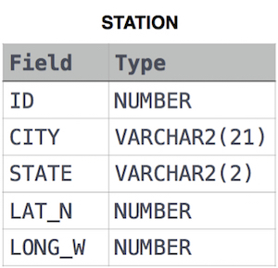

Ans.

SELECT CITY, STATE

FROM STATION